~~ Ballet on Horseback ~~
Vaulting Camp
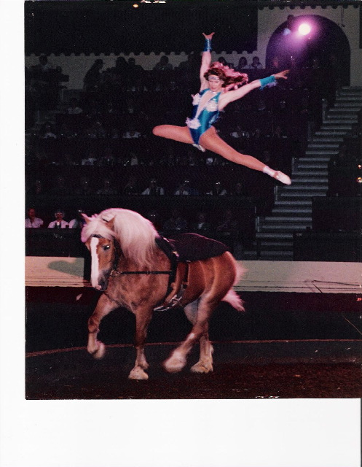

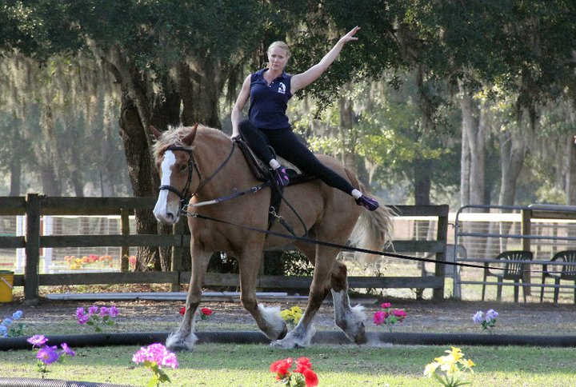
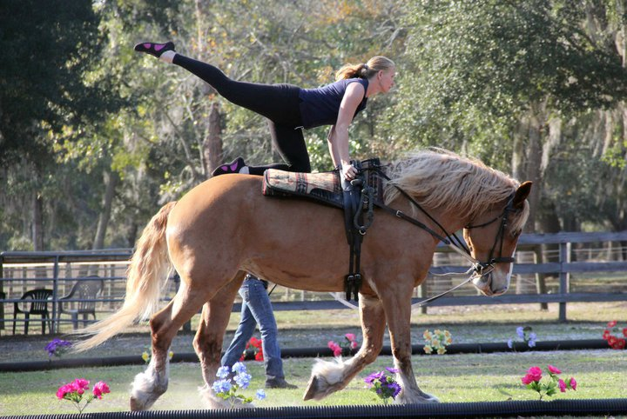

USEF Compulsory Techniques
And
Performance Vaulting/Taught by Kiersten Main
$275.00/child
9:00 a.m. – 1:00 p.m.
Campers must bring lunch, snacks and drinks provided
Limited Space Available
Ages 7 & up
June 27th through July 1st
Devonwood Farms
215 Woodward Drive
Aiken, SC 29803
www.devonwoodfarms.com
Contact: Wendy 803 502 1000

